Q1: Find out the total no of users in the dataset

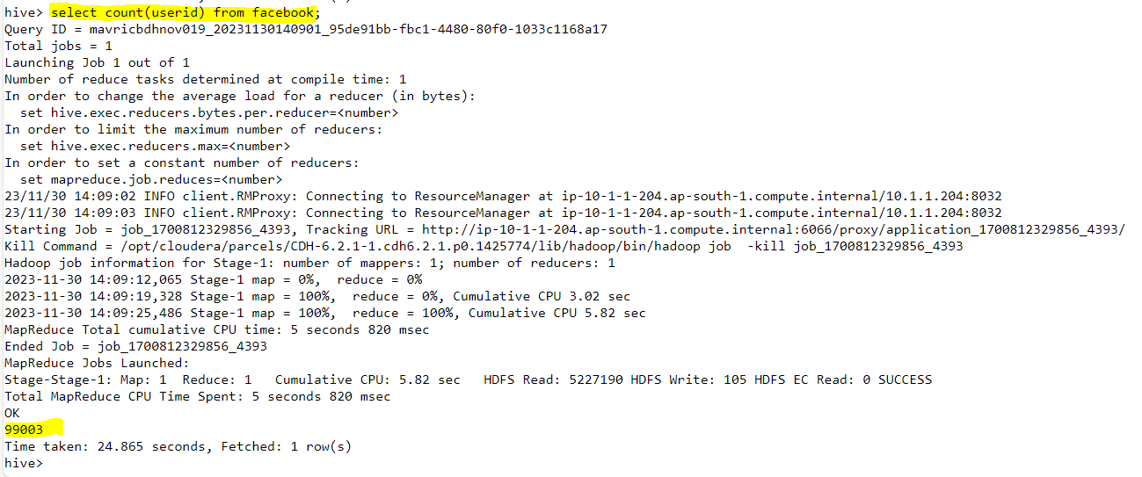

Q2: Find out the no of users above the age of 25

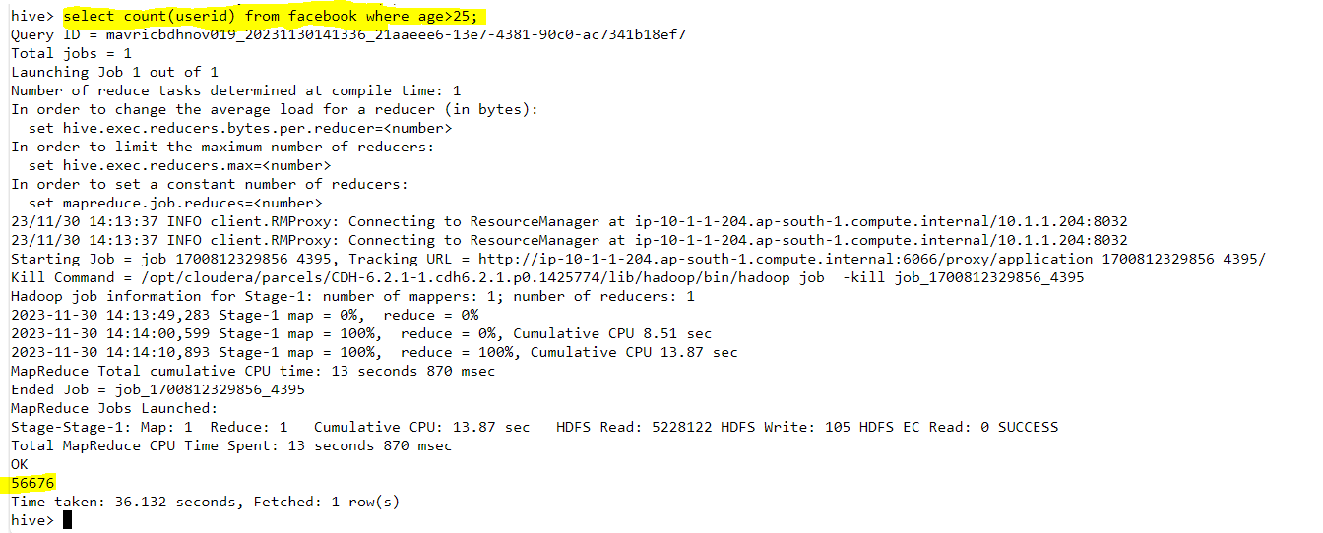

Q3: Do male face book users tend to have more friends or female users

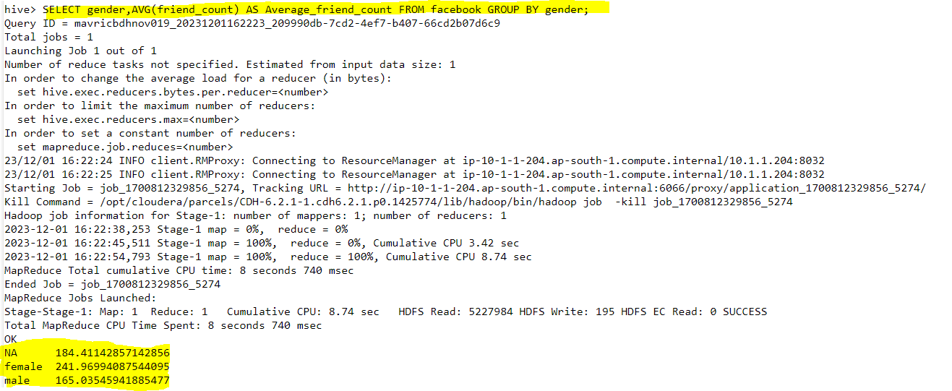

Q4: How many likes do young people receive on facebook as opposed to old people

Q5: Find out the count of facebook users for each birthday month

SELECT dob_month, COUNT(*) AS user_count FROM facebook GROUP BY dob_month ORDER BY dob_month;

Q6: Do young members use mobile phones or computers for facebook browsing

WITH age_device AS (

SELECT

CASE

WHEN age < 30 THEN 'Young'

ELSE 'Old'

END AS age_group,

CASE

WHEN mlikes > 0 THEN 'Mobile'

ELSE 'Computer'

END AS device_type

FROM facebook

)

SELECT

age_group,

device_type,

COUNT(*) AS user_count

FROM age_device

GROUP BY age_group, device_type;

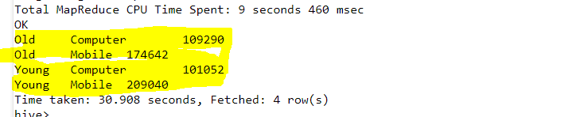

Q7: Do adult members use mobile phones or computers for facebook browsing

SELECT

age_group,

device_type,

COUNT(*) AS user_count

FROM (

SELECT

CASE WHEN age >= 18 THEN 'Adult' ELSE 'Not Adult' END AS age_group,

CASE WHEN mobile_likes > 0 THEN 'Mobile' ELSE 'Computer' END AS device_type

FROM facebook

) subquery

GROUP BY age_group, device_type;

